“I created an Azure AI Search index from Blob Storage, enabled semantic search, and connected it as a knowledge source to my AI agent for RAG-based learning responses.”
- Agent creation in Azure AI Foundry
- Storage Account provisioning
- Blob container creation + document upload (knowledge corpus)
- Azure AI Search service creation and verification
- Index + indexer setup from Blob Storage
- Search Explorer query validation
- Adding Azure AI Search as an agent tool/knowledge source for RAG
- Prompting/testing the agent to confirm grounded responses
Created Agent using Azure AI Foundry
Created a new agent in Azure AI Foundry and configured the basic settings (name, model, and instructions) to serve as the orchestration layer for the RAG experience.
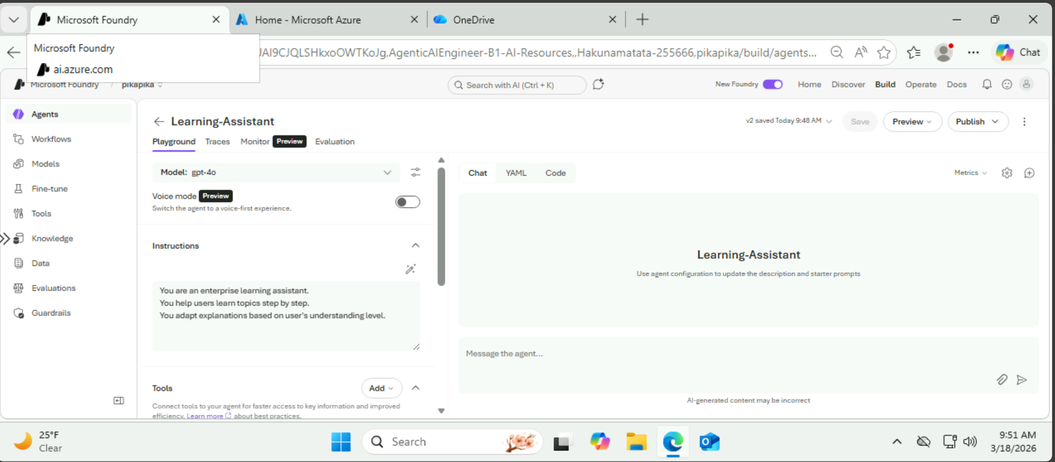
Created a Storage Account
Provisioned an Azure Storage Account to host the source documents that will be indexed and used by the agent for retrieval.
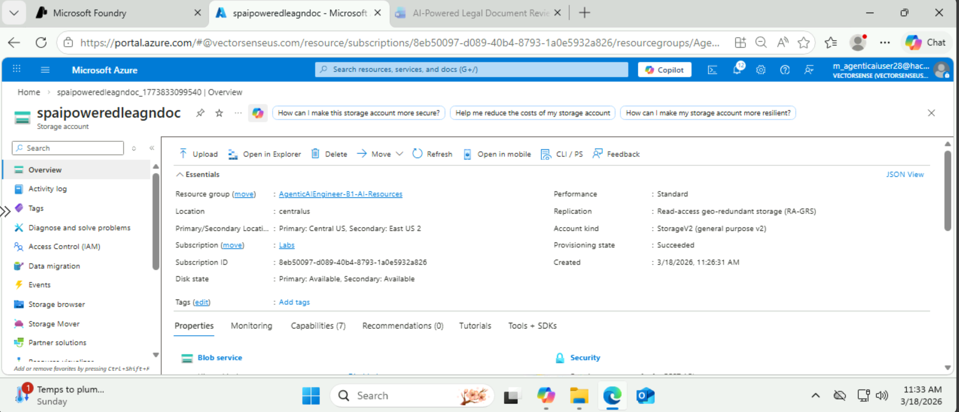
Created Blob Storage Container & Uploaded documents within the container
Created a Blob container inside the storage account and uploaded the reference files. These documents act as the knowledge corpus that Azure AI Search will ingest and index.
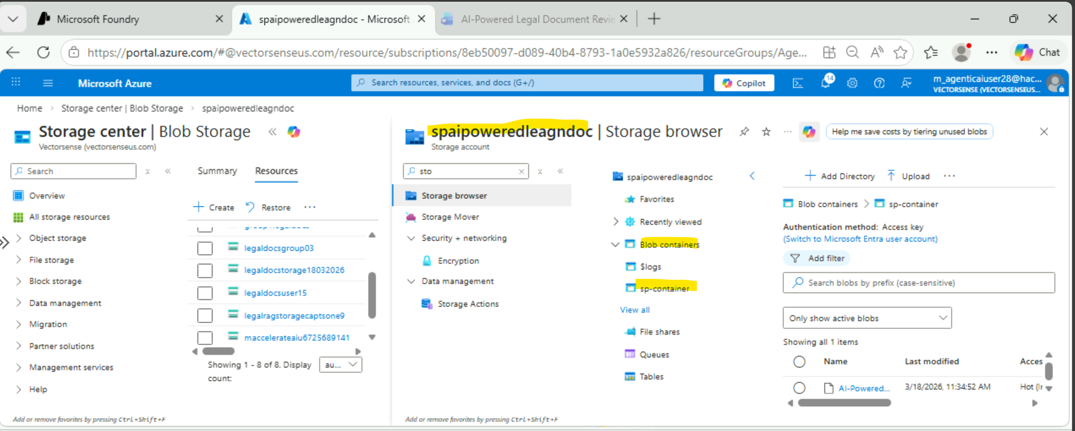

Created Azure AI Search
Provisioned an Azure AI Search (Cognitive Search) service that will store the searchable index and power keyword and semantic retrieval over the uploaded documents.
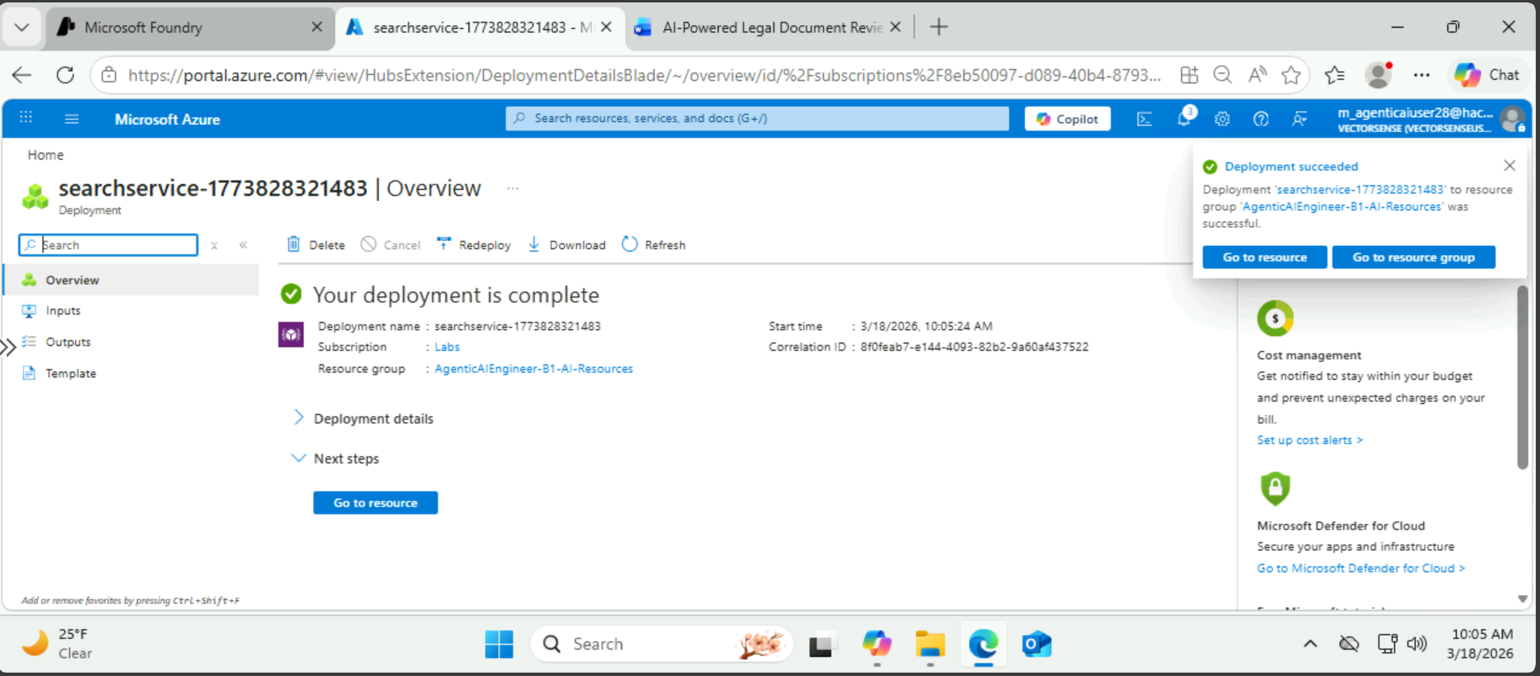
Azure AI Search got created
Verified the AI Search resource was successfully deployed and ready to be configured with data sources, indexes, and indexers.
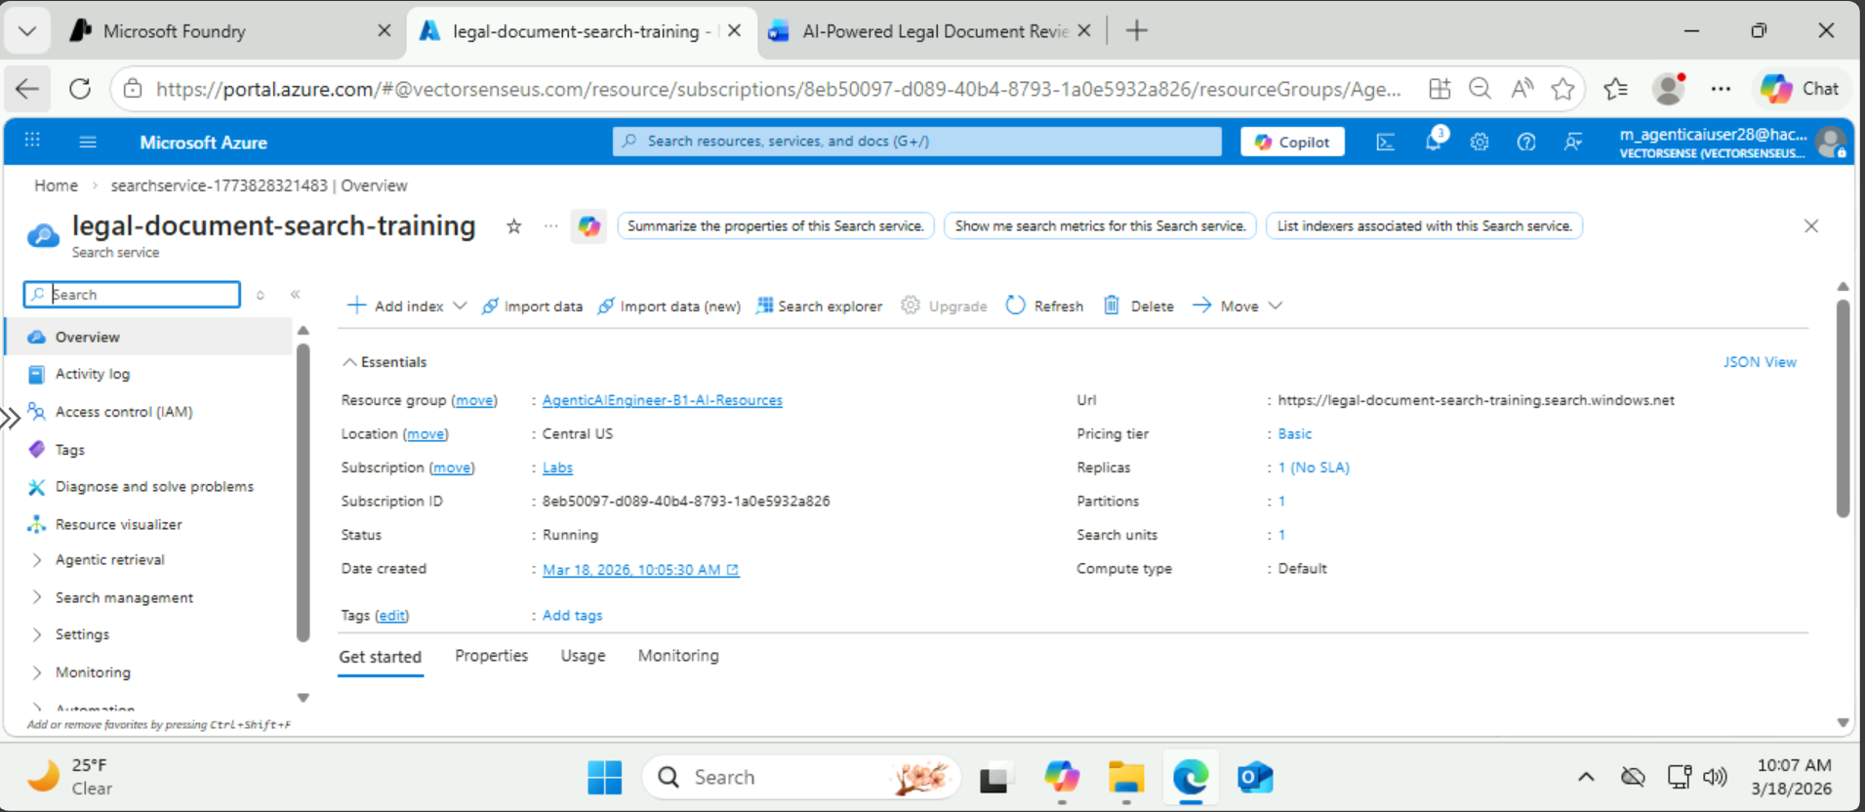
Created Indexes & Indexers
Configured the data source to point to the Blob container, created the search index schema, and ran an indexer to extract and load document content into the index (enabling it for retrieval).
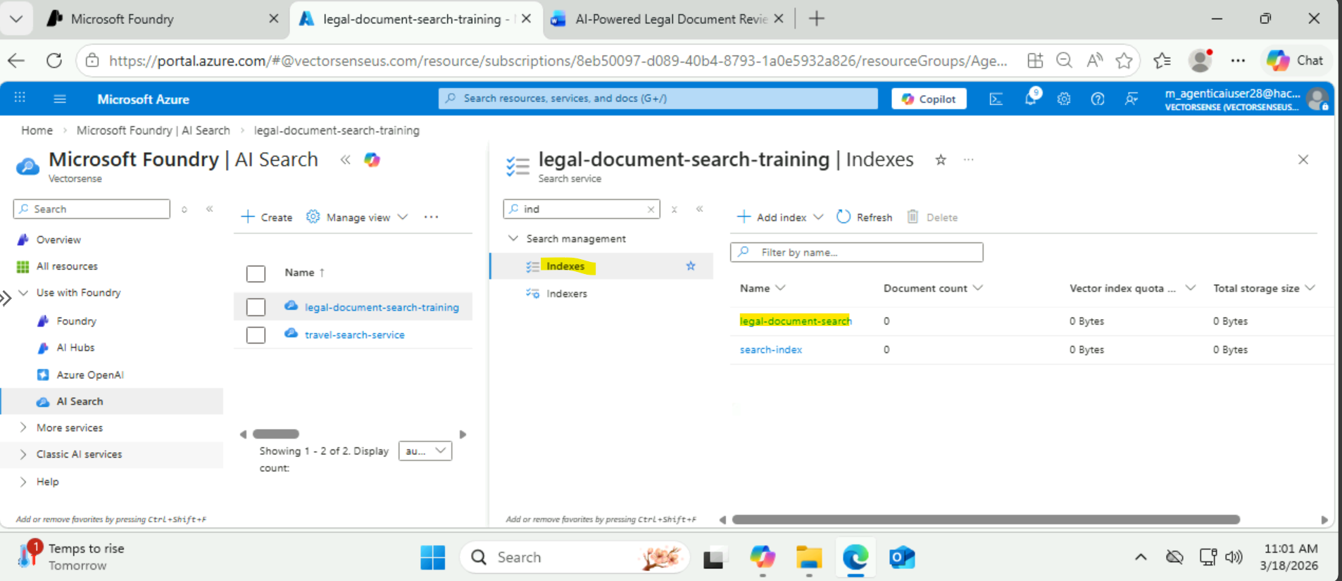
In Search Explorer, searched the content using keyword and result got appeared
Validated indexing by running a sample query in Search Explorer. The returned results confirmed that the documents were successfully ingested and could be retrieved via keyword search.
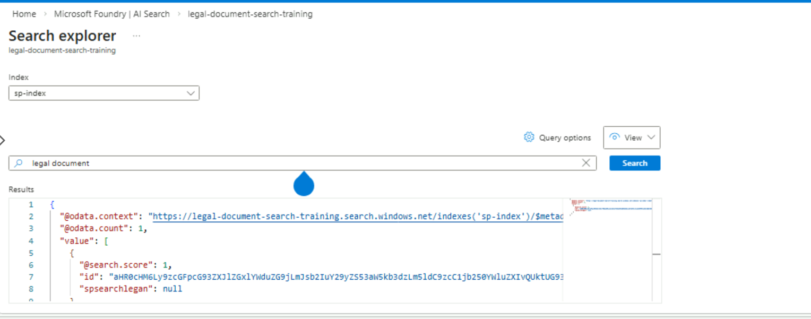

From an Agent, Added Azure AI Search as a tool
Connected the Azure AI Search index to the agent by adding it as a tool/knowledge source, so the agent can retrieve relevant passages at run time and ground its responses (RAG).
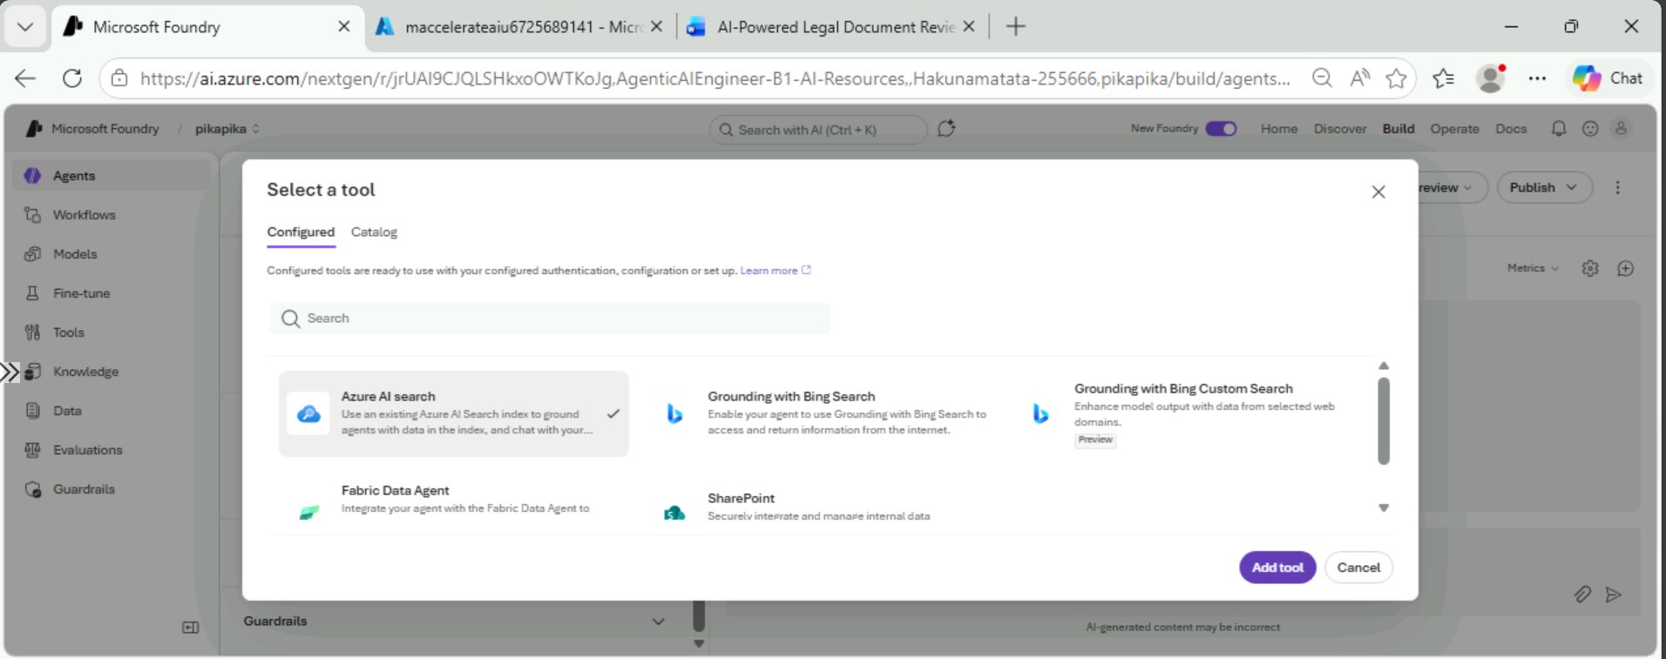

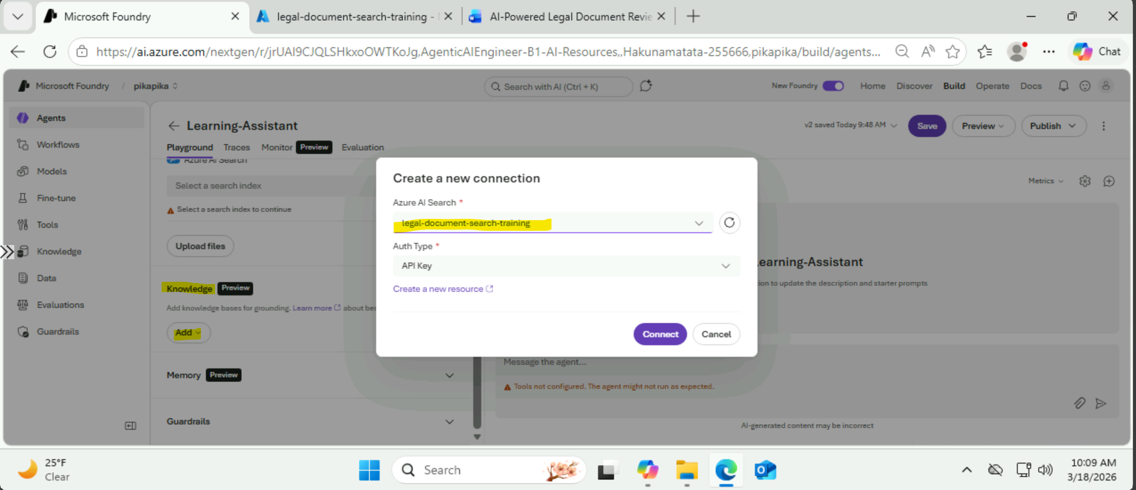

Gave a prompt to my agent and agent gives response against my prompt
Tested the end-to-end flow by prompting the agent. The agent used Azure AI Search to retrieve relevant content from the indexed documents and generated a grounded response based on the retrieved information.
